

GENERAL COGNITIVE

ABILITY TEST (GCAT)

SELECT
  - Sam Sample
4 November 2025
Distributed by People Central LTD


© Podium Systems Limited.

Introduction

 | The Assessment
The General Cognitive Ability Test (GCAT) is a measure of cognitive ability. Cognitive ability is important because it influences how quickly somebody can learn, how readily they can adapt, how easily they can understand, and how adeptly they can solve novel problems. It is well established that cognitive ability predicts educational and occupational success and is an important ingredient of future potential. The GCAT assesses ability in the following areas:
- Understanding problems using words  - Logical deduction and induction  - The relationship between numbers |  |  | - Discerning patterns and sequences  - Abstract reasoning  - Mental rotation
 | The Report
This report has been designed to support interview and reference checking processes. The report presents Canaan’s results and provides probing interview questions to help users elicit information about his preferences, past behaviour and performance.
 | Private and Confidential
This is a confidential assessment report. This report was requested for a specific purpose and has influenced the information and conclusions drawn. The information contained in this report should only be interpreted by a trained professional, and in the context of other relevant information (i.e., actual experience, interests, skills, and aptitudes).
 | Waiver
When reading this report, please remember that it is based exclusively on the information gathered from the test session only and describes performance exclusively on the GCAT test. The publishers, therefore, accept no responsibility for decisions made using this assessment and cannot be held responsible for the consequences of doing so.
 | Rating Scale
Charts in this report are described in terms of a standardised Sten score that is presented on a scale of 1 to 10 and which allows us to compare participant results. As a guide, scores of 1 to 3 are considered well below average, while scores of 5 to 6 are average, and scores of 8 to 10 are considered well above average. |  |  |  |  | Below Average | Somewhat Below Average |  | Average | Somewhat Above Average | Above Average
 | Comparison Group (Norm)
The following norm group was used to compare results against.
Assessment |  | Name |  |  |  |  | Size
GCAT |  | New Zealand Participants (2021) |  |  |  |  | 6954

Results Summary
General Reasoning
General Reasoning refers to overall General Mental Ability (g) which is an approximate overall indicator of the ability to reason, think logically, and solve problems using words, numbers, and simple images.
- Sam Sample’s general reasoning score suggests that his overall level of reasoning ability is in the slightly below average range and he may be a little less able than others to understand problems, tackle complicated tasks and make use of learning.

The following elements are used to describe the results.
Percentile Score (%ile) | Is a value on a scale of 100 that reflects the percentage of people in a sample who score below the participant's score.
Range | This is a qualitative indicator that is based on the Sten score and indicates how well a participant has performed using a 5-point score band.
Sten Score (1-10) | A Sten score is a standardised measure used to compare participant results. Presented on a 10-point scale, a score of 1 indicates low performance and a score of 10 indicates high performance.

Profile Charts
Scale | %ile | Range | Below Average | Average | Above Average
General Reasoning (overall g) | 21 | Slightly Below Average | 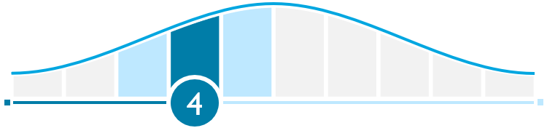
Abstract Reasoning | 18 | Slightly Below Average
Numerical Reasoning | 21 | Slightly Below Average
Verbal Reasoning | 36 | Average | 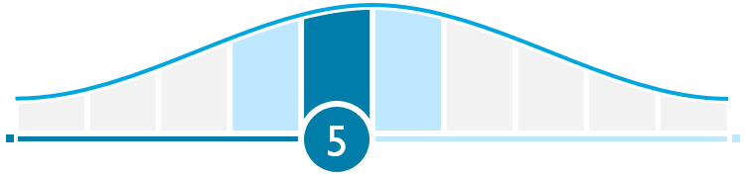

Results in Detail
Abstract Reasoning
Abstract Reasoning looks at the ability to identify logical relationships between abstract forms. It is about understanding information and grasping new concepts. It is not strongly related to previous learning. As such, it can be used to predict intellectual potential and the capacity to be trained.
- Sam Sample’s abstract reasoning score shows that he has performed in the slightly below average range when compared to the reference group.
- This result suggests that he should be able to comprehend new, unclear or complex concepts, yet it may take him a little longer than the average person.
- Therefore, he may appreciate time to comprehend new or particularly complex information.
Numerical Reasoning
Numerical Reasoning looks at the ability to spot relationships between numbers. It is about identifying, interpreting, and analysing numerical information. It can be used to predict job performance, especially for roles that work with numbers.
- Sam Sample’s numerical reasoning score places him in the slightly below average range when compared to the reference group.
- This result suggests that he may find it a little harder than the average person to comprehend numerical concepts and may take some time to fully appreciate more complex types of numerical problems.
- He should, however, be sufficiently capable of benefiting from further training and development.
Verbal Reasoning
Verbal Reasoning examines the ability to identify relationships between concepts described in words. It is about thinking, reasoning, and solving problems based on verbal concepts. It can be used to predict job performance, especially when it depends on previous learning.
- Sam Sample’s verbal reasoning score places him within the average range when compared to the reference group.
- His score suggests that he should understand verbal concepts with little difficulty, although he may prefer to have time on his side to effectively deal with more complex verbal problems.

Interview Prompts
The following questions have been designed to support the interview and reference checking process for Sam Sample by attempting to elicit information about his abilities, past performance.
Each scale has been mapped to a series of interview questions and colour coded using the following convention:
 | reflect below average results |  |  | reflect average results |  |  | reflect above average results

Use the interview questions as a guide to probe Sam Sample’s preferences, past behaviour and performance as well as how these may be applied to future role requirements.
Abstract Reasoning |  | - Describe a time when you were able to solve a problem by looking beyond the obvious facts.  - Tell me about a time when your ability to see connections between concepts helped you solve a problem in a unique way.  - Give me an example of a time when you put something you learned to good use.
Abstract Reasoning | Notes:
Numerical Reasoning |  | - Describe a recent problem that you were able to identify and how you identified it.  - Give me an example of a time when you analysed and interpreted numerical information in order to solve a problem.  - Do you work with numerical information? If so, what kind of information is it and how do you make the best use of it in your work?
Numerical Reasoning | Notes:
Verbal Reasoning |  | - Tell me about a difficult or complex idea that you explained to others.  - Give me an example of a time when you had difficulty explaining your thoughts to others.  - Describe a difficult decision you made that involved evaluating conflicting information.
Verbal Reasoning | Notes:

